EXPERIMENT 12

CURSORS

**Aim:**

1. Create a table with attributes students and marks.
2. Insert values into the table.
3. Create a procedure, and fetch the marks of given id using a cursor.
4. Create a procedure, and fetch the highest marks using a cursor.

1.



2.



3.

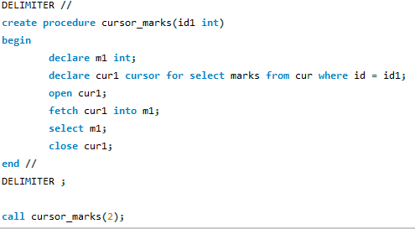



4.

